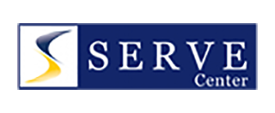
2018 National Foster Care Summit
Hosted by the SERVE Center at UNCG
Greensboro, NC
October 2-3, 2018

Tuesday, October 2, 2018

9:00-9:30 Welcome and Introductions
9:30-10:30 Interview Activity
10:30-10:45 Morning Break
10:45-12:15 What the Law Says About Education for Students in Foster Care
12:15-1:45 Lunch
1:45-3:15 The Who, When, Where, and How of Transporting Students
3:15-3:30 Afternoon Break
3:30-5:00 Doing More With Less: Funding Services for Students in Foster Care

Wednesday, October 3, 2018

9:00-9:15 Greetings and Announcements
9:15-10:00 Scenario Sessions/Conversations with GAO
10:00-10:15 Morning Break
10:15-11:30 When the Answer Isn’t Clear: Effective Practices for Dispute Resolution
11:30-12:15 Scenario Sessions/Conversations with GAO
12:15-1:45 Lunch
1:45-3:00 Compliance Monitoring: An Opportunity for Growth
3:00-3:15 Afternoon Break
3:15-4:00 Scenario Sessions/Conversations with GAO
4:00-4:30 Identifying Next Steps & Closure

